OSPF Fundamental Terminology Explained

* OSPF stands for Open Shortest Path First.
* OSPF is a link state open standard based routing protocol.
* It was created in mid-1980.
* Since it is based on open standard, we can use it with any vendor’s router.

OSPF Neighborship Condition and Requirement

* OSPF routers share routing information only with neighbors.
* OSPF uses hello packets to discover neighbors in segments.
* A hello packet contains some essential configuration values that must besame on both routers who want to build an OSPF neighborship.

Area ID

* OSPF uses area concept to scale an enterprise size network.
* Just for reference, OSPF areas create a logical boundary for routing information.
* By default routers do not share routing information beyond the area.
* So in order to become neighbor, two routers must belong to same area.

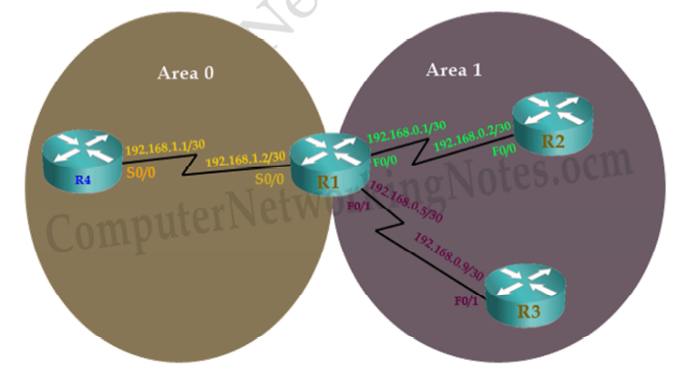

* In this network R1 is eligible to form neighborship with R4 and R2 respectively on S0/0 and F0/0.

Why neighborship cannot be built between R1 and R3?

* ***Both interfaces should be in same area.*** Yes both interfaces ( R1’sFo/1 and R3’s F0/1) are in same area.
* ***Both interfaces should be in same segment.*** Yes both interfaces ( R1’sFo/1 and R3’s F0/1) are connected with direct link.
* ***Both interfaces should have same subnet mask.*** Yes both interfaces have same subnet mask /30.
* ***Both interfaces should have same network ID.*** No both interfaces have different network ID. R1’s F0/1 has network ID 192.168.0.4/30 while R3’s F0/1 has network ID 192.168.0.8/30. This condition does not match. Thus these two routers on these interfaces cannot build neighborship.

***Router(config-if)#bandwidth 64*** Bandwidth works as an influencer. It is used to influence the metric calculation of OSPF or any other routing protocol which uses bandwidth parameter in route selection process. Serial interface has default bandwidth of 1544Kbps.

**To explain, how bandwidth influence route selection process we will configure (64Kbps) bandwidth on three serial DCE interfaces of our network; R0’s Se0/0/0, R1’s Se0/0/1 and R2’s Se0/0/0. Configure default bandwidth of 1544Kbps to all other routers.**

**Configure OSPF routing protocol**

Enabling OSPF is a two steps process:-

* Enable OSPF routing protocol from global configuration mode.
* Tell OSPF which interfaces we want to include.

For these steps following commands are used respectively.

Router(config)# **router ospf** *process_ID*  
Router(config-router)# **network** *IP_network_#* [*wild card mask*]**Area** *area_number*

Router(config)# **router ospf** *process ID*

This command will enable OSPF routing protocol in router. Process ID is a positive integer. We can use any number from 1 to 65,535. Process ID is locally significant. We can run multiple OSPF process on same router. Process ID is used to differentiate between them. Process ID need not to match on all routers.

Router(config-router)# **network** *IP_network_#* [*wildcard_mask*] area [*area number*]

Network command allows us to specify the interfaces which we want to include in OSPF process. This command accepts three arguments network number, wildcard mask and area number.

Network number

Network number is network ID. We can use any particular host IP address or network IP address. For example we can use 192.168.1.1 (host IP address) or we can use 192.168.1.0 (Network IP address). While targeting a specific interface usually we use host IP address (configured on that interface).

While targeting multiple interfaces, we use network IP address. So any interface that belongs to specified network ID will be selected.

Wildcard mask

Wildcard mask are used with network ID to filter the interfaces. Wildcard mask is different from subnet mask. Subnet mask is used to separate the network portion and host portion in IP address. While wildcard mask is used to match corresponding octet in network portion. Wildcard mask tells OSPF the part of network address that must be matched. Wildcard masks are explained with examples in access list tutorials of this category.

Key points

0 (Decimal – octet format) Wildcard mask indicates that corresponding octet in network address must be matched exactly.

255 (Decimal – octet format) Wildcard mask indicates that we don’t care about corresponding octet in network address.

For example

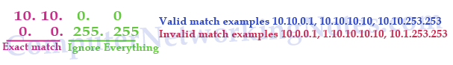

0 (Binary – bit format) Wildcard mask indicates that corresponding bit in network address must be matched exactly.

255 (Binary – bit format) Wildcard mask indicates that we don’t care about corresponding bit in network address.

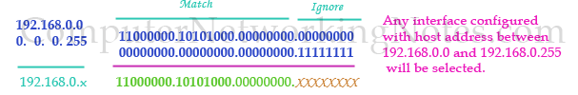

For example we want to exclude serial interfaces in above configuration. We can use a wildcard mask of 0.0.0.255 to match the subnet mask of /24.

Router(config-router)# network 172.168.1.0 0.0.0.255

Router(config-router)# network 172.168.2.0 0.0.0.255

|  |  |
| --- | --- |
| Command | Description |
| Router(config)#router opsf 10 | Enable OSPF routing protocol under process ID 10. |
| Router(config-router)#network 10.10.0.0 0.0.255.255 area 0 | Enable OSPF with area 0 on matching interface. |
| Router(config)#interface loopback 0 | Create a Loopback interface and move in sub interface configuration mode |
| Router(config-if)#ip address 192.168.250.250 255.255.255.0 | Assign IP address to loopback interface. |
| Router(config-router)#router-id 1.1.1.1 | Set 1.1.1.1 as router ID |
| Router(config)#interface serial 0/0 | Inter in sub interface configuration mode |
| Router(config-if)#ip ospf priority 100 | Used to influence DR/BDR selection process. Valid range is 0 to 255. 0 makes router ineligible for DR/BDR while 255 makes router guaranteed DR/BDR. Higher priority value means higher chance of becoming DR/BDR. |
| Router(config-if)#bandwidth 256 | Used to influence route metric cost. Cost is the inverse of bandwidth. Higher bandwidth has lower cost. Bandwidth is defined in Kbps. 256 means 256 Kbps. |
| Router(config-if)#ip ospf hello-interval timer 15 | Set hello interval timer to 15 seconds. Hello timer must be match on both routers in order become neighbors. |
| Router(config-if)#ip ospf dead-interval 60 | Set dead interval timer to 60 seconds. Dead interval timer must be match on both routers in order to become neighbor |
| Router#show ip route | Display all routes from routing table |
| Router#show ip route ospf | Display all routers learned through OSPF from routing table |
| Router#show ip ospf | Display basic information about OSPF |
| Router#show ip ospf interface | Display information about all OSPF active interfaces |
| Router#show ip ospf interface serial 0/0/0 | Display OSPF information about serial 0/0/0 interface |
| Router#show ip ospf neighbor | List all OSPF neighbors with basic info |
| Router#show ip ospf neighbor detail | List OSPF neighbors with detail info |
| Router#show ip ospf database | Display data for OSPF database |
| Router#clear ip route * | Clear all routes from routing table. |
| Router#clear ip route 10.0.0.0/8 | Clear particular route from routing table |
| Router#clear ip ospf counters | Clear OSPF counters |
| Router#debug ip ospf events | Display all ospf events |
| Router#debug ip ospf packets | Display exchanged OSPF packets |
| Router#debug ip ospf adjacency | Display DR/BDR election process state |

| Device | Interface | IP Configuration | Connected with |
| --- | --- | --- | --- |
| PC0 | Fa0/0 | 10.0.0.2/8 | Router0’s Fa0/0 |
| Router0 | Fa0/0 | 10.0.0.1/8 | PC0’s Fa0/0 |
| Router0 | Fa0/1 | 192.168.1.1/30 | Router5’s Fa0/1 |
| Router5 | Fa0/1 | 192.168.1.2/30 | Router0’s Fa0/1 |
| Router5 | Fa0/0 | 192.168.1.5/30 | Router6’s F0/0 |
| Router6 | Fa0/0 | 192.168.1.6/30 | Router5’s Fa0/0 |
| Router6 | Fa0/1 | 20.0.0.1/8 | Server0’s Fa0/0 |
| Server0 | Fa0/0 | 20.0.0.2/8 | Router6’s Fa0/1 |
| Router0 | Serial 0/0/0 (DCE) | 192.168.0.1/30 | Router1’s Se0/0/0 |
| Router1 | Serial 0/0/0 | 192.168.0.2/30 | Router0’s Se0/0/0 |
| Router1 | Serial 0/0/1 (DCE) | 192.168.0.5/30 | Router2’s Se0/0/1 |
| Router2 | Serial0/0/1 | 192.168.0.6/30 | Router1’s Se0/0/1 |
| Router2 | Serial 0/0/0 (DCE) | 192.168.0.9/30 | Router6’s Se0/0/0 |
| Router6 | Serial 0/0/0 | 192.168.0.10/30 | Router2’s Se0/0/0 |
| Router0 | Serial 0/0/1 | 192.168.2.1/30 | Router3’s Se0/0/1 |
| Router3 | Serial 0/0/1 (DCE) | 192.168.2.2/30 | Router0’s Se0/0/1 |
| Router3 | Serial 0/0/0 | 192.168.2.5/30 | Router4’s Se0/0/0 |
| Router4 | Serial 0/0/0 (DCE) | 192.68.2.6/30 | Router3’s Se0/0/0 |
| Router4 | Serial 0/0/1 | 192.168.2.9/30 | Router6’s Se0/0/1 |
| Router6 | Serial0/0/1 (DCE) | 192.168.2.10/30 | Router4’s Se0/0/ |

